Company Name: Big Fire Bull Financial Investment Co., Ltd.

Company Number: 20241510157

Registered Address: 555 17th St, Denver, CO 80202, United States

Big Fire Bull Financial Investment Co., Ltd. Company Profile

Big Fire Bull Financial Investment Co., Ltd., referred to as BigFireBull, is an innovative Web3 and AI technology company, a cryptocurrency trading and investment platform. Its engineers and investment team have served Elon Musk in the establishment of an artificial intelligence startup (X.AI). The Big Fire Bull artificial intelligence super online client has been successfully developed. Since its establishment, it has been committed to financial innovation and technological research and development, and has rapidly developed into a leader in the field of cryptocurrency investment. The company adheres to the core values ​​of "innovation, professionalism, security, and win-win", and is committed to providing investors with efficient, intelligent and secure financial services.

BigFireBull has a profound historical background, and its founding team is composed of a group of elites with rich financial investment experience and deep technical skills. They have insight into the huge potential of the cryptocurrency market and firmly believe that AI technology will set off a revolution in the field of financial investment. As a result, BigFireBull came into being, and with its forward-looking strategic vision and strong technical strength, it quickly gained a foothold in the market.

The company's main business covers multiple fields, including cryptocurrency spot and contract trading, AI intelligent trading system, airdrop distribution, ETH staking to earn coins, AI intelligent mining, ICO new coin subscription and other functions. BigFireBull's AI intelligent trading system is one of its core competitiveness. The system can analyze market data in real time, accurately predict price trends, and help investors make more informed investment decisions. At the same time, the company also provides investors with more income channels through airdrop rewards, ETH staking to earn coins and other methods.

It is worth mentioning that BigFireBull is holding a top cryptocurrency trader competition. This is an event aimed at discovering and cultivating outstanding trading talents. Participants only need to use BigFireBull's AI intelligent trading system to participate in transactions and have the opportunity to win a million-dollar bonus. This not only demonstrates the company's confidence in technology, but also reflects the company's emphasis on talent training.  
  
--------------------------  
  
You can click this link to view our company information👇👇

<https://www.coloradosos.gov/biz/BusinessEntityDetail.do?quitButtonDestination=BusinessEntityResults&nameTyp=ENT&masterFileId=20241510157&entityId2=20241510157&fileId=20241510157&srchTyp=ENTITY>  
  
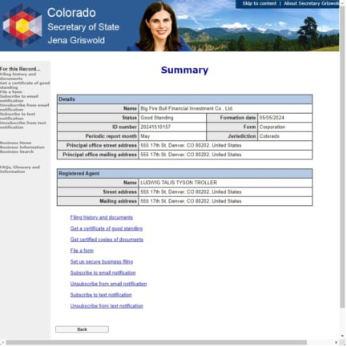  
  
  
------------------------  
  
  
The US MSB is a type of financial regulatory license issued by the US Financial Crimes Enforcement Agency for digital currency, foreign exchange, and futures. US companies engaged in digital currency, foreign exchange, futures and other financial businesses must obtain a US MSB license in order to operate in compliance!

This is our MSB license👇👇  
  
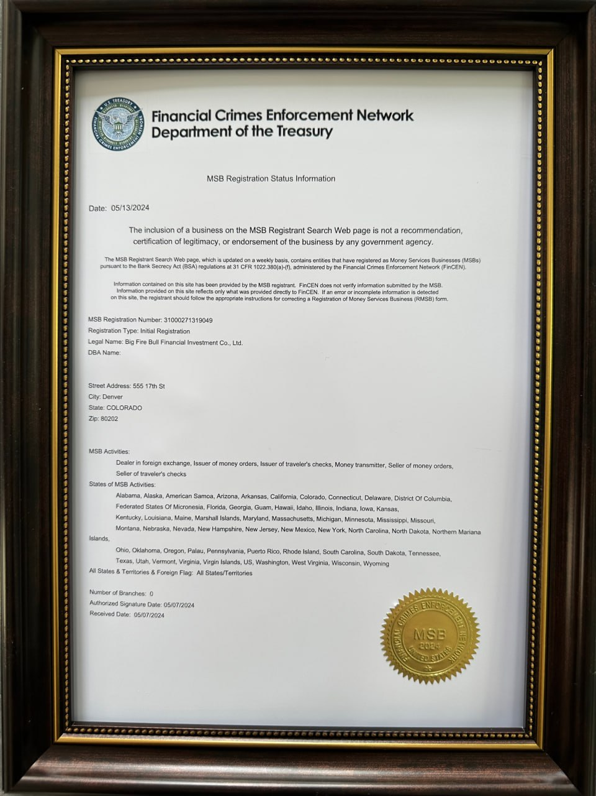  
  
--------------  
  
A business license is a permit issued by a government agency that allows a person or company to conduct business within the territory of a specific government entity. Its main tasks are to ensure accountability of business operations, ensure public safety, and track revenue collection.

This is our business license 👇👇  
  
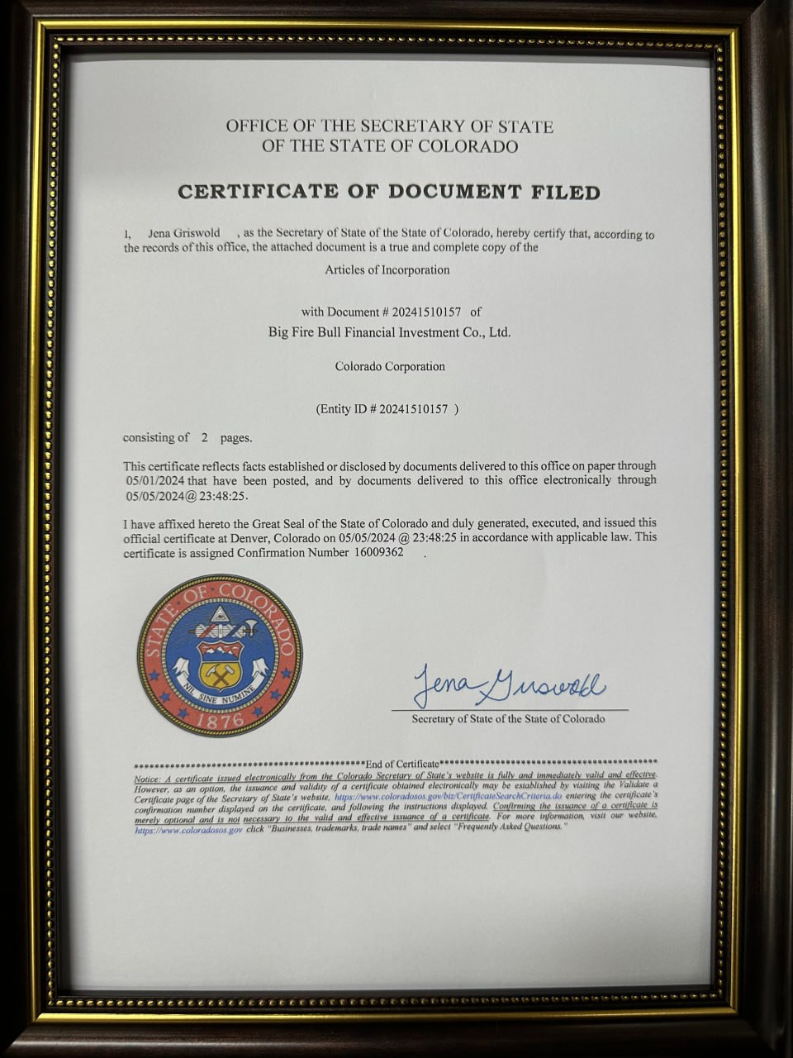  
  
----------------  
  
  
The US company's certificate of good standing, also known as the Certificate of Good Standing, is a document issued by the relevant government registration and approval department. It is used to prove that the US company legally exists at the state level, has paid all required government fees, and complies with all administrative regulations and requirements. In addition, this certificate also proves that the company has submitted an annual report and is in "good standing"

This is our company's certificate of good standing👇👇  
  
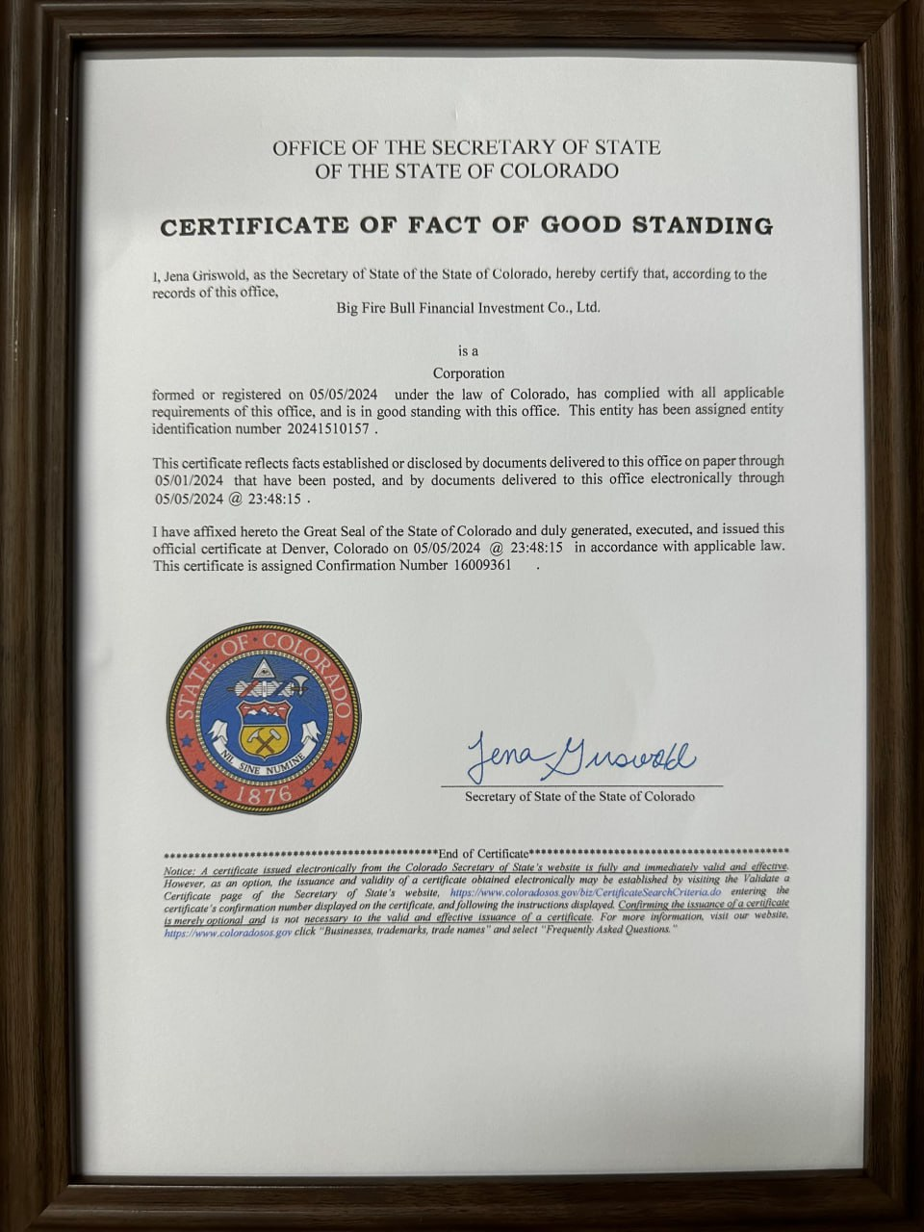  
  
------------------------  
  
  
  
**The above information is 👆🏻👆🏻**

**Big Fire Bull Financial Investment Co., Ltd.**

**Company profile, our formal, legal, and supervised investment company! If you need to check with me, please contact me!**